Chapter 16, Problem 60.

Find the response v_{R}(t) for t > 0 in the circuit in Fig. 16.83. Let R = 3 Ω, L = 2 H, and C = 1/18 F.
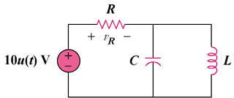

Figure 16.83
For Prob. 16.60.

